13. Viverone – Santhia
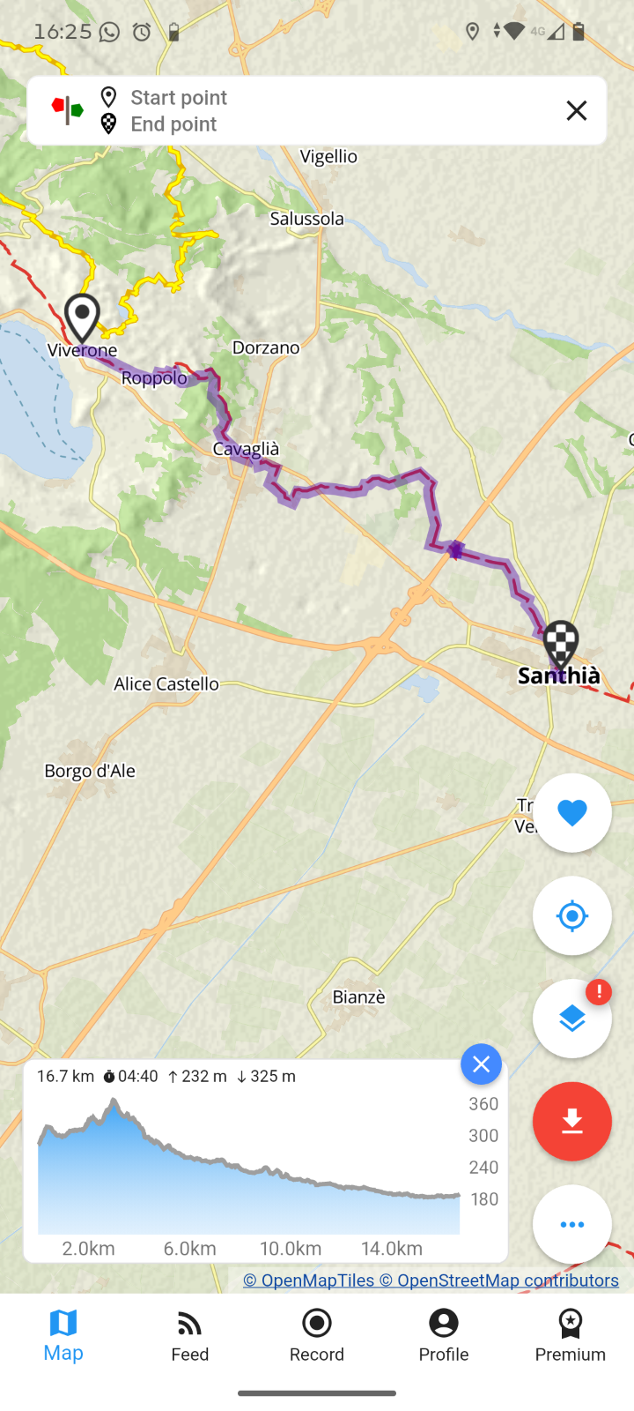
13th^{th} June

Accomodation Santhia

Ostello Amici della Via Francigena di Santhià
Address: Corso Nuova Italia 134, 13048, Santhià, Vercelli, Italy
Phone Numbers: +39 3886333865
Email: info@santhiasullaviafrancigena.it
Hostel with 24 beds, divided into 3 apartments
Hostel, No. of places available: 24, divided between 3 apartments
Donation hostel (reservation only!)

